|  | **JSPM’s**  **RAJARSHI SHAHU COLLEGE OF ENGINEERING**  **TATHAWADE, PUNE-33**  **(An Autonomous Institute Affiliated to Savitribai Phule Pune University,Pune)** |  |
| --- | --- | --- |

**Department of Information Technology**

**Innovation by Faculties in Teaching Learning**

1. **Statement of Clear Goal, Use of appropriate methods, Significance of results, Effective presentation**

**Name of the Course:** Internet of Things

**Name of the Faculty:** Prof.U.L.Tupe

**Name of the Innovative Method used:** Educational Youtube Video

**Name of the topic:** Introduction of Internet of Things

**Statement of Clear Goal**:

The goal of YouTube channel is to provide a comprehensive and easy-to-understand Internet of Things and through the channel covers fundamental concept of IOT and communication between Sensors. The objective is to create a space for practical insights, enhancing their understanding and application of IOT in both academic and professional contexts with visual contents

**Significance of result:**

The IoT represents a new technology that aims to link a large number of sensor-enabled devices, and it's critical to examine the difficulties and obstacles that come with implementing IoT-oriented networks in smart cities. Sensor nodes have become smarter and more capable of gathering data without human intervention nowadays . Since their inception, WSNs have been recognized as key enablers for the IoT and have evolved into a platform for deploying a wide range of significant smart city applications, including "transportation and roadside applications, air pollution monitoring, smart parking, automated control systems, and other IoT-oriented applications"The significance of showcasing this implementation on a YouTube channel is twofold:

1. **Educational Value:** It helps viewers understand a key mechanism in IOT, which is foundational for IOT Sensors and their working. The IOT demonstrates how to manage data flow between Sensors, which is essential for understanding input/output operations of sensors their working and applications.
2. **Real-World Applications:** This video emphasize practical implementation IOT is used in modern smart cities, Agriculture, embedded systems, and real-time applications. This help viewers relevance of IOT in managing communication between sensors in real-world embedded software development, from scratch.

**Effective Presentation (Screenshot):**

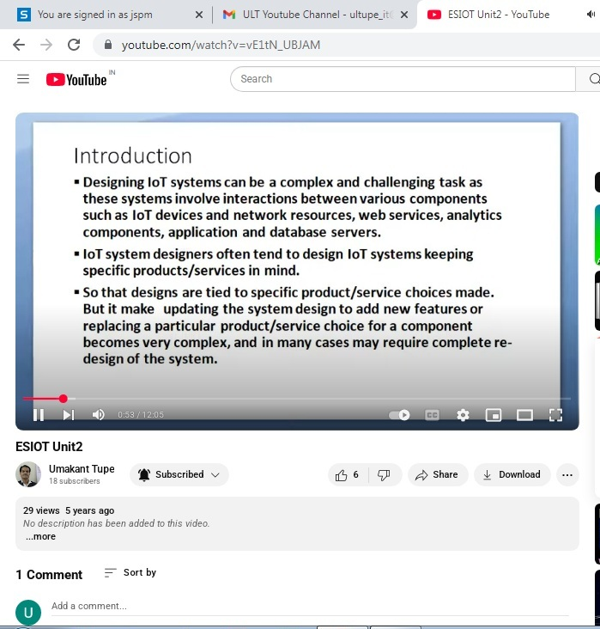

**Peer Review and Critique (Feedback):** Comments of videos.

1. **Availability of work related to Innovation by Faculty in Teaching and Learning is on Institute website.**

[**https://www.jspmrscoe.edu.in/information-technology/innovation-practices**](https://www.jspmrscoe.edu.in/information-technology/innovation-practices)

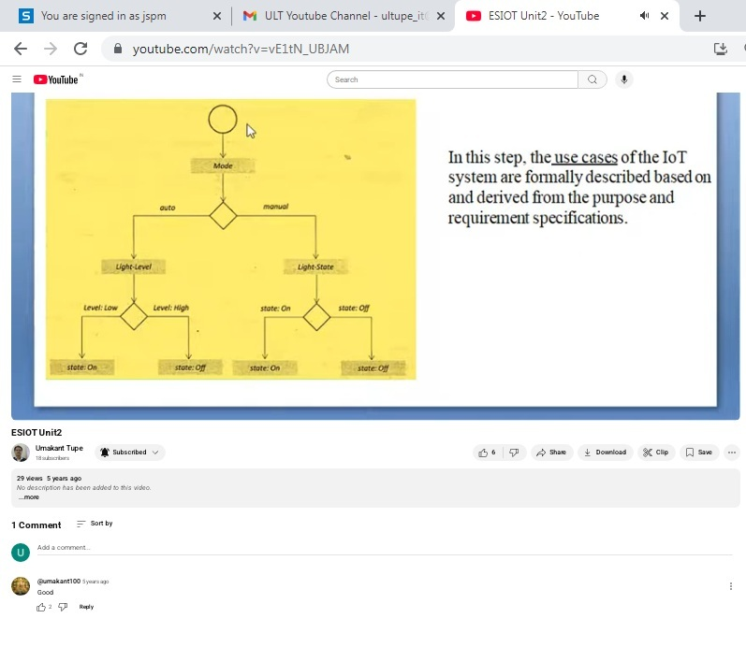

**C.Availability of work for peer review and critique.**

[**https://github.com/jspmIt/ULT**](https://github.com/jspmIt/ULT)



**D: Reproducibility and Reusability by other scholars for further development**

* **Views**, **likes**, **comments**, and **shares: P**eople are engaging with and potentially applying the content.
* Students are forwarding video to other for watching
* Students are giving Comments
* Viewers are thinking critically and considering extensions
* This video is linked to GitHub repositories. Viewers can **download and can** modify it.

The link of github repository is as follows:

<https://github.com/users/umakanttupe/projects/1/views/1?layout_template=table>

| **Sr.No** | **Innovation Used by** | **Details of User** | **Purpose of**  **Reproducibility and Reusability** |
| --- | --- | --- | --- |
| **1.** | **YouTube Video** | **Prof.U.L.Tupe** | To allow viewers to **repeat the process or concept** shown in the video and obtain the same results.  To. Encourage knowledge sharing and collaboration. |

**Course Co-ordinator Module Co-ordinator HOD**

Prof.U.L.Tupe Dr. S.M. Chaware Dr. Nihar M. Ranjan